> library (forecast)

> library(ggplot2)

> library(tidyverse)

> library(tsibble)

# Open the file "pset1.csv"

> x = read.csv("pset1.csv")

# Assign variables atm to the full dataset and atmHOLD to the dataset leaving out the last 6 observations

> atm = ts(x[,2],start=c(1958,3),end=c(2021,1),frequency=12)

> atmHOLD = ts(x[,2],start=c(1958,3),end=c(2020,7),frequency=12)

# 1.a) Naive forecast

> naive(atmHOLD, h=6)

Point Forecast Lo 80 Hi 80 Lo 95 Hi 95

Aug 2020 414.38 412.7942 415.9658 411.9547 416.8053

Sep 2020 414.38 412.1373 416.6227 410.9501 417.8099

Oct 2020 414.38 411.6333 417.1267 410.1793 418.5807

Nov 2020 414.38 411.2084 417.5516 409.5294 419.2306

Dec 2020 414.38 410.8340 417.9260 408.9569 419.8031

Jan 2021 414.38 410.4956 418.2644 408.4393 420.3207

# 1.b) Sample Mean forecast

> meanf(atmHOLD, h=6)

Point Forecast Lo 80 Hi 80 Lo 95 Hi 95

Aug 2020 355.3577 318.4067 392.3086 298.8044 411.9109

Sep 2020 355.3577 318.4067 392.3086 298.8044 411.9109

Oct 2020 355.3577 318.4067 392.3086 298.8044 411.9109

Nov 2020 355.3577 318.4067 392.3086 298.8044 411.9109

Dec 2020 355.3577 318.4067 392.3086 298.8044 411.9109

Jan 2021 355.3577 318.4067 392.3086 298.8044 411.9109

# 2. Plot data

> autoplot(atm)

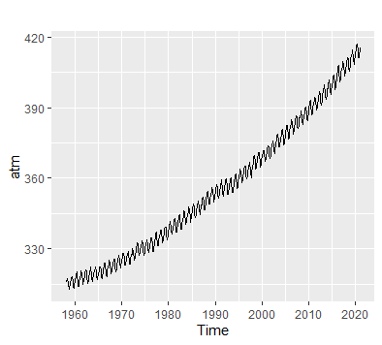

# Comments: There is a upward trend in this dataset. There is also a apparent seasonality

# 3.a) Personally I would choose multiplicative forecast error

# to minimize the error scale for easier observing the data.

# The trend can either be Additive or Multiplicative Damped,

# but I would choose Additive since the data appears somewhat linear.

# Since seasonality exists in this dataset and appears to be

# constant, the most appropriate Exponential Smoothing method

# should be Holt-Winters Additive.

> hw(atmHOLD, h=6)

Point Forecast Lo 80 Hi 80 Lo 95 Hi 95

Aug 2020 412.5307 412.1265 412.9348 411.9126 413.1488

Sep 2020 411.1642 410.7054 411.6229 410.4625 411.8658

Oct 2020 411.4862 410.9771 411.9953 410.7076 412.2647

Nov 2020 413.1050 412.5488 413.6612 412.2544 413.9556

Dec 2020 414.4909 413.8900 415.0918 413.5719 415.4098

Jan 2021 415.7807 415.1370 416.4244 414.7963 416.7652

# 3.b) Create a plot containing the forecast values, upper and lower confidence bands,

# and the actual values of atmospheric CO2

> f6 = hw(atmHOLD, h=6)

> attributes(f6)

# Obtain actual data including a small amount of data prior to the forecast period. (from 2020, January)

> actualvalue=window(atm,start=c(2020,1))

> actualvalue

Jan Feb Mar Apr May Jun Jul Aug

2020 413.39 414.11 414.51 416.21 417.07 416.38 414.38 412.55

2021 415.28

Sep Oct Nov Dec

2020 411.29 411.28 412.89 414.02

2021

# Obtain forecast value

> forecastvalue=f6$mean

> forecastvalue

Jan Feb Mar Apr May Jun Jul Aug Sep

2020 412.5307 411.1642

2021 415.7807

Oct Nov Dec

2020 411.4862 413.1050 414.4909

2021

# Obtain the upper and lower bands

> Upper95=f6$upper[,2]

> Upper95

Jan Feb Mar Apr May Jun Jul Aug Sep

2020 413.1488 411.8658

2021 416.7652

Oct Nov Dec

2020 412.2647 413.9556 415.4098

2021

> Lower95=f6$lower[,2]

> Lower95

Jan Feb Mar Apr May Jun Jul Aug Sep

2020 411.9126 410.4625

2021 414.7963

Oct Nov Dec

2020 410.7076 412.2544 413.5719

2021

# Create a union and plot it

> X=ts.union(actualvalue,forecastvalue,Upper95,Lower95)

> autoplot(X)

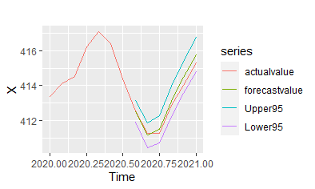

# 4. Forecast the CO2 level in the next 40 years

> hw(atmHOLD, h= 40*12)

Point Forecast Lo 80 Hi 80 Lo 95 Hi 95

Aug 2020 412.5307 412.1265 412.9348 411.9126 413.1488

Sep 2020 411.1642 410.7054 411.6229 410.4625 411.8658

Oct 2020 411.4862 410.9771 411.9953 410.7076 412.2647

Nov 2020 413.1050 412.5488 413.6612 412.2544 413.9556

Dec 2020 414.4909 413.8900 415.0918 413.5719 415.4098

Jan 2021 415.7807 415.1370 416.4244 414.7963 416.7652

Feb 2021 416.4610 415.7761 417.1460 415.4134 417.5086

Mar 2021 417.2449 416.5199 417.9700 416.1361 418.3538

Apr 2021 418.7598 417.9957 419.5239 417.5912 419.9283

… excerpted only

> f40 = hw(atmHOLD, h= 40*12)

> autoplot(f40)

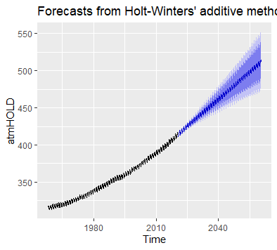

# Using my chosen model earlier, I strongly believe that

# atmospheric CO2 level are projected to rise above 450 ppm within the next 40 years.

# According to the forecasted data, this will occur around April 2034

# (by looking at the forecast model f40 or the plot)